**Effects of biological and environmental covariates on the size-weight relationships of Eastern and Northern Bering Sea crab stocks and derived biomass estimates**

Jonathan I. Richar

**Abstract**

The modeled size-weight relationship is a critical component in expanding fishery independent survey-derived data to create population estimates for Bering Sea crab stocks. Current procedures assume this relationship to be constant across a range of crab physiological parameters, environmental conditions and geographic range for the purpose of creating biomass estimates. Effects of shell condition, environmental temperature, and region on the size-weight relationships of red king crab, blue king crab, opilio and Bairdi crab were assessed. For female Bairdi and opilio, effects of clutch size were also evaluated. Population biomass estimates were derived using calculated model parameters, and compared to estimates calculated using the current fixed parameters. Old shell crab were found to be heavier for a given size in all models, with some variability in the slope of the size-weight relationship across sizes. New shell crab were found to generally weigh less for a given size in cold years, particularly when comparisons were constrained to only the warmest and coldest years, though with exceptions. Results for models considering clutch size were mixed, and species dependent. Large differences between eastern and northern Bering Sea stocks were also observed. Relative to estimates calculated using the current standard models for these stocks, male biomass estimates were modestly larger when applying shell-condition based models, particularly for Bairdi, with some interannual variability. These results suggest that it may be appropriate to reconsider and update current biomass estimation procedures used in stock assessment for at least for certain stocks.

**Introduction**

Red king crab, blue king crab, Bairdi and opilio crab form the basis of economically valuable fisheries in the eastern Bering Sea (EBS). In the norther Bering Sea (NBS), interest in opilio and blue king crab is likely to increase with anthropogenic climate change, while Norton Sound red king crab have supported locally important commercial and subsistence fisheries. An important component of both effective fishery management, and understanding population trends for these stocks is the calculation of biomass estimates based on size frequencies, through the use of size-weight models based on a subset of the survey catch. The current model implementations used to generate estimates for these stocks assume a constant relationship across a range of environmental conditions and crab ages post molt, with the only allowances made being sex and for females, maturity status-specific models (Zacher et. al 2020).

Individual crab weights may however be influenced by factors beyond the size of the given individual. Crab which have not molted recently are likely to have communities of encrusting organisms growing on their carapace, including hydroids, barnacles and tunicates. . Because epibionts are a factor considered when distinguishing between new shell (NS) and old shell (OS) crab, OS crab, which usually have a much more epibiont growth, are likely to be more affected than NS crab, which typically have little or none (Jadamec 1999). Notably, because affected crab weigh more than comparable individuals with clean carapaces, due to the additional mass of these organisms, efforts are made to either exclude such crab from being weighed altogether or at a minimum, remove these epibionts from the carapace prior to weighing,

The size-weight relationship is also likely to be influenced by relative meat fill (i.e. the amount of soft tissue) within the crab’s carapace, which is itself influenced by both the time elapsed since last molt, and the crab’s condition. Because OS crab will have had more time for tissues to develop since their last molt, it is likely that they will have greater meat fill than their NS counterparts. Importantly, temperature can influence both individual condition and time elapsed since last molt by altering molt intervals (Chilton et al. 2010; Stevens 1990), and thermally stressing the given crab (Azra et al. 2020). Consequently, a crab’s environment may also influence the size-weight relationship, particularly when the crab is sampled under rigid, standardized procedures, such that crab in a given area will be sampled at the same time every year.

A crab’s size-weight relationship is likely to be influenced, albeit to a lesser degree, by mineralization and condition of the carapace. This is related to the time elapsed post-molt; increasing with time to a certain point, then declining as the crab approaches the graveyard stage and senescence. Old shell (SC3) crab are likely to have the most mineralized and densest carapace structure, while new shell (SC2) and very old shell/grave yard (SC4/5) crab will have comparatively less mineralized and less dense carapaces; the former due to limited time to mineralize post-molt, the latter due to age-related deterioration and shell disease.

Finally, a consideration unique to mature female crabs is the effect of the egg clutch on the measured weight of the given female crab. Although it may be expected that egg clutches will contribute to the measured weight, survey personnel do not currently remove egg clutches prior to weighing a mature female crab. Furthermore, it is reasonable to expect that larger egg clutches will result in greater weights for the given female, relative to a same-sized crab with a smaller clutch.

In the work presented here, size-weight relationships are modeled based on shell condition (SC) for male Bristol Bay red king crab (BBRKC), St. Matthew blue king crab (SMBKC), and both male and female EBS *Chionoecetes bairdi* (EBS CB) and *C. opilio* (EBS CO). These models are then used to assess the degree to which the use of SC specific size weight models alters population biomass estimates that are used in the assessment of these stocks. For female EBS CB and EBS CO, effects of clutch size (CS) on the size-weight relationship within shell condition categories were also considered. In addition, the effects of temperature on the size-weight relationship in new shell male and female BBRKC, EBS CO and EBS CB is investigated. Finally, size-weight models are created for Norton Sound red king crab (NS RKC), Northern Bering Sea blue king crab (NBS BKC) and Northern Bering Sea *C. opilio* (NBS CO) for the purpose of evaluating regional differences that arise in this relationship between these stocks and their EBS counterparts.

**Methods**

For the greater EBS region, crab were sampled during summer bottom trawl surveys conducted by the Alaska Fisheries Science Center during June-August in the years 2000-2019, though there were inconsistencies in sampling effort, and weights were not taken during all years in this series (Tables 1, 2, 3). For the NBS, crab were sampled in August-September for the years 2010, 2017-2019, and 2021-2022. For thermal-regime based models, years were classed as being “warm” or “cold” based on whether a retow was conducted for Bristol Bay red king crab. This is done in years when cool conditions in Bristol Bay delay the female molt-mate cycle, such that a significant proportion of the population have not completed this life cycle event at the time of initial sampling in late May or early June (Table 1).

Individual length/width is currently measured to the nearest 0.1 mm using digital calipers while prior to 2015 measurements were taken using Vernier calipers. In addition, prior to 2006, measurements were taken to the nearest 1 mm only. Crab weights were measured to the nearest 2 g via a digital scale. Shell condition, which is used as an index for time elapsed since the most recent molt, and is based on carapace wear and epibiont accumulation, was classified as per standardized protocols (Jadamec 1999). For analysis purposes, SC2 crab were categorized as NS, while SC3 and SC4 crab were combined into an OS group. Small sample sizes prevented consideration of SC4 crab separately. Poor crab condition, and heavy epibiont growth typical of the SC5 state lead to even smaller sample sizes for this category, in addition to concern about quality of these measurements, and these crab were excluded from model development. Small sample sizes also prevented robust calculation of size-weight models for OS NBS CO, thus size-weight models for this stock incorporated all shell conditions, with a focus on evaluating regional differences. Respective measurement sample sizes by species, sex, SC, year and thermal regime of sampling year may be found in Tables 1 and 2. For female models considering the effect of clutch-size, only EBS CB and EBS CO females were investigated, for clutch-sizes of ½, ¾, and full, as it was felt that classification protocols for these clutch sizes and in the species were the most reliable. For these females, separate models were run for pooled crab by shell condition across clutch-size categories, and by clutch-size category within shell condition groups. Finally, for all thermal-effect models, only SC2 crab were used, to limit potential for confounding by conditions in prior years.

For analysis, the allometric size-weight relationship for each group may be modeled as

[1]

where *W* is the measured weight in g, *L* is the corresponding carapace size measurement (length/width) in mm, and *a* and *b* are model estimated parameters. This model was linearized via log-transformation as

[2] ,

which then permitted parameter estimation via linear modeling methodologies using the statistical software R ((R Development Core Team 2019). The use of the natural log maintained strict consistency with procedures used for the current standard size-weight model parameters. Initial models were tested for outliers, using Cook’s Distance, and any such data points were then removed prior to the fitting of final size-weight models. Using the final fitted models, Analysis of Covariance (ANCOVA) procedures were used to test for equality of the model size-weight relationships when compared between SC and thermal regime groups.

Because a final objective for this work was to develop size-weight models that may be applied for stock assessment purposes, all available data were employed to ensure that models were representative of all size classes sampled. Old shell males are however more prevalent at larger size classes, leading to a mismatch in size ranges represented in the data, which may drive model differences between NS and OS groups. To address this, for BBRKC, EBS CB and EBS CB males, NS males were subset into two secondary data series; the first with a size cutoff corresponding to the size of the smallest observed OS males (BBRKC, >79 mm; EBS CB, >40 mm; EBS CO, > 36 mm), and the second with a cutoff corresponding to the lower boundary for upper 3 quartiles of OS males (BBRKC, >132 mm; EBS CB, >106 mm; EBS CO, > 76 mm). Old shell male data were also subset as per this last cutoff to maximize comparative equivalency. These data were only used to test for differences in the model relationships stemming from size compositions and parameters were not applied in further analyses (e.g. biomass estimation).

To assess the impact of considering SC specific size-weight relationships on population estimates, SQL-based analysis codes presently employed to calculate area swept biomass estimates were amended to use the SC-based size-weight model parameters in lieu of the standard parameters. For these models, individual crab weights were first calculated using the appropriate size-weight model with the new parameters, (Eq. 1) and converted to kilograms. For males, new shell models were applied to SC 1 and 2 crab, while OS models were applied to SC 0, 3, 4 and 5 crab.

Catch-per-unit-effort by weight was then calculated as

[3] ,

where CPUEWbji is the CPUE by weight in kilograms/nmi2 in size bin *b* at station *j* in year *i*, *Wb,j* is the total weight, in kg, of crab *N* in bin *b* in station *j*, *NWj* is the average net width in meters at station *j*, *Dj* is the distance fished, in km, at station *j* and *k* is a constant (0.29155335) converting km2 to nmi2. Stock biomass may then be calculated as

[4] ,

where, *CPUEWjis*is CPUE (weight) for size bin *b* at station *j*, in strata *s* and year *i*, *nsi*is the number of stations sampled in strata *s* in year *i*, and *Asi* is the area of strata *s* in year *i*. Finally, percent differences were calculated as

[5]

Where *Bn* is the biomass estimate for stock *s* in year *i* calculated using the new parameters, and *Bo* is the corresponding estimate for stock *s* in year *i* calculated using the current parameter set. Given the limited time series available with temperature classifications using this study’s classification criteria, similar population estimation procedures were not conducted using thermal-regime model parameters. Concerns about confounding of effect between clutch-size, and shell condition in females, and the need for further research to separate these effects meant that population estimates were not attempted for females.

**Results**

Estimated model parameters, and their appropriate anti-log transformed counterparts may be found in Tables (4, 5). Plotted data points and fitted model regression lines may be examined in Figs (1, 2, 3). For SC-based models, ANCOVA analyses indicated that intercepts significantly differed between groups in all comparisons (Tables 6, 7), suggesting that for a given species, study groups differed in weight for a given size. Intercept estimates further suggest that for BBRKC, SMBKC and EBS CO, OS crab are heavier at a given size. Conversely, the intercept estimates for EBS CB suggest that OS crab may be lighter at a given size than are NS males, however graphical analysis Figs (3a, 3b) suggest that this is an artifact of OS measurements being weighted towards larger crab, in combination with residual non-linearity which was not resolved by log-transformation, and OS males in fact outweigh NS males. For female models incorporating shell condition and clutch size, OS females and those with larger clutches were found to weigh more at a given size (Table 7). ANCOVA results suggest that in all SC model comparisons, excepting those for BBRKC SC, slopes were significantly different (Table 7). These findings suggest that the relationship between size and weight differs based on SC.

Limiting NS male data to the same size ranges as OS males affected model parameters, but did not fundamentally alter the SC based size-weight relationships: in all cases models still suggest that OS males are heavier for a given size than are new shell males. Because of this, models developed using concatenated data were not adapted for further use in the calculation of biomass estimates. For BBRKC, models using the 79 mm cutoff (giving a NS size range matching the size range observed in baseline OS data) did not differ significantly from baseline models (Table 4). Increasing the cutoff to 132 mm for NS males changed the slope, but did not significantly alter the intercept relative to the NS baseline, while the same cutoff increased the difference between the NS and OS models, such that slopes significantly differed (Table 4). Use of minimum size cutoffs for the NS males did not notably alter conclusions for either *Chionoecetes spp.* when comparing between SC groups. Intercepts for NS models employing data delimited using either cutoff were statistically different from baseline model intercepts; slopes however only differed in EBS CO models (Table 6).

Relative to standard weight-at-size estimates, those derived using the covariate-based models exhibited size-based variance, with the relationship differing based on the SC/CS/thermal regime (Figs 4, 5, 6, 7, 8, 9). Before proceeding, an important caveat when interpreting size-at-weight output is that due to crab biology, specifically molt intervals and for *Chionoecetes spp,* size at maturity and the associated terminal molt, OS crab only occur at or above certain sizes (RKC, 60 mm CL; BKC, 50 mm CL; CO/CB, 20 mm CW), thus model divergences below these cutoffs are biologically meaningless.

Shell condition-based model weight estimates for BBRKC, SMBKC and EBS CO most closely agreed with the standard estimates at larger sizes, while the reverse was true for EBS CB (Figure 4), with this being most pronounced for OS males (Figs 4, 8). Thermal-regime based models also exhibited size-based divergences that differed between species (Figs 5, 6, 7). In males of both *Chionoecetes spp.* Warm-regime models diverged the least, while indicating that relative to the baseline size-weight model, the temperature-based model calculated slightly smaller weights at a given size (Figure 5). Cold-regime models for these species showed the greatest divergence, albeit with contrasting trends: for EBS CB, the greatest divergence was seen at larger sizes, while for EBS CO, this occurred at smaller sizes (Figure 5). In both cases, the maximum divergence was negative, indicating the baseline model gave a larger estimate than the temperature-based. Opposing trends were also seen in BBRKC males and females: for males at smaller sizes the warm-regime model suggested greater weight-at-size, while the cold-regime model estimated lower weights-at-size, with both converging with the baseline model at larger sizes (Figure 5). For females, diverges for both thermal-regime models were positive at smaller sizes, and became increasingly negative at larger sizes (Figure 5).

For female EBS CB, trends in diverges observed in weights calculated using shell condition and clutch-size-based models were generally similar to those observed in male BBRKC, with OS, and full-clutch female models giving a larger weight than the baseline at smaller sizes, while the NS and half-full models gave a smaller weight, and all converging with the baseline at larger sizes. Interestingly, while ½ full and full-clutch NS models showed a marked difference in calculated weights at size (Figure 6e), the OS specific ½ full and full models demonstrated high similarity (Figure 6f). For female EBS CO, OS, large-clutch models gave weight-at-size estimates most similar to the baseline, with deviations being greatest at smaller sizes, and smallest at the largest sizes (Figure 7). As with EBS CB, ½ full and full OS models were much more similar than their new shell counterparts (Figs 7e and 7f).

NBS model results indicate that for NS RKC and NBS CO, baseline EBS-region models currently applied to this region will under estimate crab weights for these species at the smaller sizes most commonly encountered, while over estimating them at larger sizes more rarely encountered (Figs 9a, 9c). This was particularly true for NSRKC, where the BBRKC model underestimated OS male weights by up to ~15% within the size interval (>60 mm CL), in which such males are observed in this region. The reverse is the case for both NS and OS NBS BKC (Figure 9b).

Annual population biomass estimates calculated using SC specific models exhibited a variable relationship relative to the standard model based estimates, with EBS CB models exhibiting the greatest divergence (Figure 9). On average however, estimates diverged only modestly from the standard model biomass estimates (Table 5).

While there were species-specific as a rule, new shell crab weighed more in warm years than in cold years. Unsurprisingly, BBRKC were most consistent, with both males and mature females having significantly different size weight models between warm, and cold years (Table 4). Male EBS CB also exhibited consistently different models between thermal regimes, while female EBS CB did not (Table 4). Results for EBS CO were similarly mixed (Table 4).

**Discussion**

In the work presented here, it was demonstrated that SC, CS and environmental temperature affect the size-weight relationship in crab sampled from the eastern Bering Sea continental shelf. Furthermore it was shown that current models fitting a single size-weight relationship to all crab of a stock, regardless of SC, are likely to be biasing population biomass estimates, with the magnitude of this bias varying by SC with crab size class, and sampling year.

As previously observed, it is likely that at least a portion of the weight increase observed in OS crab relative to new shell individuals of the same size is the result of epibiont growth on their carapaces. It is however standard protocol to remove any such organisms prior to weighing, or if this is not possible, personnel will not weigh the crab in question unless remaining epibionts are considered unlikely to significantly bias the measurement (pers. observation). Consequently, the increase in weight is likely primarily due to endogenous factors—higher meat fill within the carapace, as crab will have had a year or more to fill out since their last molt, and heavier, denser carapaces due to increased calcification (Somerton and MacIntosh 1983).

Under the current standard approach of fitting a single size-weigh model, weights for OS crab are biased low, while weights for NS crab are biased high. It is likely that this is the driver for the variability observed in the biomass estimate discrepancies, particularly in EBS CB. In years with a high proportion of OS males, biomass will be underestimated using the standard model, relative to a SC based model, while in years with a high proportion of NS males, biomass is likely to be overestimated. Although the magnitudes of these discrepancies are typically small, in years of reduced population sizes, such as have recently been observed for BBRKC and EBS CB (Zacher et al. 2020), even minor errors in estimates may have an outsized effect on management decisions.

It is intriguing that slopes differed between SC class in the *Chionoecetes spp*. models, implying the existence of a size-based effect differing between SC categories. Specific identification of the major driver(s), and partitioning of the weight increase effect would however necessitate composition analysis of individual crab, combined with additional field measurements. Such measurements may include consideration of additional non-standard morphometric data that are not currently available (for example measurements of leg segment girth/length, body depth and thickness of carapace shell at different regions of the body including chelae). Such is well beyond the scope of both the current work and available data, but would comprise an important and useful follow up. Additionally, although model parameters are expected to change with alterations to the input data, the observed significant changes suggest it may be worthwhile to consider piecewise size-weight models fitted to specific size intervals.

Findings for female suggest that as with males, OS crab weigh more at a given size than do NS crab, however findings for the clutch-size based models support the hypothesis of a confounding effect by egg clutches. Consequently, it may not be appropriate to use weights obtained from clutch bearing female crab. As an alternative, it may be appropriate to strip all eggs from clutch bearing females prior to weighing them. This may however be controversial at present, due to the current depleted status of the major EBS crab stocks, and so this may be a project for future consideration in the event that crab stocks recover (Zacher et al. 2023). It is both interesting that in OS females, clutch-size appears to have much more limited effect on the size-weight relationship than in NS females, particularly for EBS CB, suggesting that shell condition may have a more pronounced effect on crab weight than the egg mass in these crab. An alternative, and more concerning interpretation is that evaluations of clutch-size, specifically for OS females are not as reliable as was assumed.

Finally, it is likely that the differences observed between cold and warm year size-weight relationships observed in most study groups stem from either a delay in molting reducing the time available for new tissue growth prior to sampling, reduced tissue growth rate, or a combination thereof. Although the models used to generate biomass estimates for the purposes of the work presented here did not do so, it may be advisable to exclude NS males sampled during colder years from analyses seeking to set a size-weight relationship for use in stock assessments, as these data are likely to bias resultant estimated model parameters.

**References**

Azra, M.N., Aaqillah-Amr, M.A., Ikhwanuddin, M., Ma, H., Waiho, K., Ostrensky, A., dos Santos Tavares, C.P., Abol-Munafi, A. B. 2020. Effects of climate-induced water temperature changes on the life history of brachyuran crabs. Rev. Aquacult. 12: 1211-1216.

Chilton, E. A., R. J. Foy, and C. E. Armistead. 2010. Temperature effects on assessment of red king crab in Bristol Bay, Alaska, p. 249-263. *In* Kruse, G. H., G. L. Eckert, R .J. Foy, R. N. Lipcius, B. Sainte-Marie, and D. Stram (eds.), Biology and management of exploited crab populations under climate change. University of Alaska Fairbanks, Alaska Sea Grant Rep. No 10-01.

Jadamec, L.S., Donaldson, W.E., Cullenberg, P. 1999. Biological field techniques for Chionoecetes crabs. Fairbanks: University of Alaska Sea Grant report 99-02: 80 pp.

R Core Team (2019). R: A language and environment for statistical

computing. R Foundation for Statistical Computing, Vienna, Austria. URL

<https://www.R-project.org/>.

Stevens, B.G. 1990. Temperature-dependent growth of juvenile red king crab (*Paralithodes camtschaticus*) and its effects on size-at-age and subsequent recruitment in the eastern Bering Sea. Can. J. Fish. Aquat. Sci. 47: 1307-1317.

Somerton, D.A. and MacIntosh, R.A. 1983. Weight-size relationships for three populations in Alaska of the blue king crab Paralithodes platypus (Brandt, 1850) (Decapoda, Lithodidae). Crustaceana 45: 169-175.

Tamone, S.L., Adams, M.M., Dutton, J.M. 2005. Effect of eyestalk-ablation on circulating ecdysteroids in haemolymph of snow crabs, *Chionoecetes opilio*: physiological evidence for a terminal molt. Integr. Comp. Biol. 45: 166-171.

Tamone, S.L., Taggart, S.J., Andrews, A.G., Mondragon, J. and Nielsen, J.K. 2007. The relationship between circulating ecdysteroids and chela allometry in male Tanner crabs: evidence for a terminal molt in the genus *Chionoecetes*. J. Crustacean. Biol. 27: 635-642.

Zacher, L.S., Richar, J.I. and Foy, R.J. 2020. The 2019 eastern and northern Bering Sea continental shelf trawl surveys: Results for commercial crab species. U.S. Department of Commerce NOAA Technical Memorandum NMFS-AFSC-400, 234 p.

Zacher, L.S., Richar, J.I., Fedewa, E.J., Ryznar, E.R. and Litzow, M.A. (2023) The 2022 eastern and northern bering Sea continental shelf trawl surveys: results for commercial crab species, U.S. Department of Commerce, NOAA technical memorandum NMFS-AFSC-462, 253 p.

|  |  |  |  |  |  |  |  |
| --- | --- | --- | --- | --- | --- | --- | --- |
| Year | BBRKC – NS | BBRKC – OS | EBS CB – NS | EBS CB – OS | EBS CO – NS | EBS CO – OS | Thermal regime |
| 1975 | 0 | 0 | 0 | 0 | 32 | 8 | NA |
| 2000 | 184 | 107 | 217 | 43 | 145 | 43 | Cold |
| 2001 | 135 | 21 | 103 | 12 | 122 | 5 | Warm |
| 2006 | 218 | 28 | 129 | 66 | 322 | 122 | Cold |
| 2007 | 172 | 85 | 137 | 135 | 281 | 68 | Cold |
| 2008 | 20 | 28 | 10 | 0 | 1 | 0 | Cold |
| 2009 | 112 | 30 | 108 | 107 | 180 | 101 | Cold |
| 2010 | 183 | 40 | 583 | 200 | 382 | 236 | Cold |
| 2011 | 121 | 52 | 95 | 74 | 342 | 112 | Cold |
| 2012 | 176 | 75 | 448 | 165 | 674 | 334 | Cold |
| 2013 | 109 | 42 | 4 | 0 | 646 | 232 | Warm |
| 2014 | 0 | 0 | 503 | 225 | 0 | 0 | Warm |
| 2015 | 146 | 17 | 0 | 0 | 337 | 328 | Warm |
| 2016 | 0 | 0 | 253 | 349 | 0 | 0 | Warm |
| 2017 | 160 | 38 | 120 | 265 | 555 | 301 | Cold |
| 2018 | 0 | 0 | 759 | 512 | 28 | 12 | Warm |
| 2019 | 114 | 21 | 11 | 12 | 717 | 200 | Warm |

Table 1. Male sample sizes by species, shell condition, and thermal classification for sample year, determined based on requirement for a late summer retow at select stations. NS = new shell, OS = old shell. BB, BBRKC = Bristol Bay red king crab, EBS CB = EBS Bairdi, EBS CO = EBS opilio.

|  |  |  |  |  |  |  |
| --- | --- | --- | --- | --- | --- | --- |
| Year | SMBKC -NS | SMBKC -OS | EBS CB -  Matfem - NS | EBS CB -  Matfem - OS | EBS CO -  Matfem - NS | EBS CO -  Matfem - OS |
| 2000 | 1 | 2 | 15 | 17 | 36 | 27 |
| 2001 | 5 | 1 | 25 | 4 | 60 | 0 |
| 2006 | 25 | 3 | 27 | 19 | 231 | 65 |
| 2007 | 77 | 13 | 36 | 31 | 158 | 28 |
| 2008 | 62 | 27 | 27 | 84 | 212 | 122 |
| 2009 | 116 | 31 | 15 | 44 | 104 | 58 |
| 2010 | 267 | 30 | 58 | 140 | 441 | 144 |
| 2011 | 119 | 26 | 36 | 80 | 339 | 126 |
| 2012 | 113 | 73 | 0 | 0 | 0 | 0 |
| 2013 | 46 | 3 | 0 | 0 | 657 | 58 |
| 2014 | 74 | 28 | 48 | 217 | 0 | 0 |
| 2015 | 54 | 16 | 0 | 0 | 432 | 219 |
| 2016 | 37 | 9 | 20 | 40 | 0 | 0 |
| 2017 | 22 | 3 | 18 | 42 | 546 | 94 |
| 2018 | 68 | 6 | 93 | 111 | 0 | 0 |
| 2019 | 100 | 27 | 21 | 0 | 354 | 119 |

Table 2. Sample sizes by shell condition for male St. Matthew blue king crabs (SMBKC) and mature female (Matfem) Bairdi (EBS CB) and opilio (EBS CO).

|  |  |  |  |  |  |
| --- | --- | --- | --- | --- | --- |
| Year | NS RKC - Male - NS | NS RKC - Male - OS | NBS BKC - Male - NS | NBS BKC - Male - OS | NBS CO - Male - All |
| 2010 | 26 | 23 | 13 | 4 | 173 |
| 2017 | 38 | 5 | 47 | 10 | 425 |
| 2018 | 0 | 2 | 2 | 3 | 7 |
| 2019 | 68 | 11 | 17 | 1 | 352 |
| 2021 | 18 | 10 | 13 | 2 | 0 |
| 2022 | 10 | 13 | 23 | 9 | 593 |

Table 3. Sample sizes by shell condition for male Norton Sound red king crab (NS RKC), northern Bering Sea blue king crab (NBS BKC) and northern Bering Sea opilio (NBS CO). New shell = NS, old shell = OS. Note all shell conditions pooled for NBS CO (All).

|  |  |  |  |  |
| --- | --- | --- | --- | --- |
| Model | a | b | a* | b* |
| BBRKC - Male - Standard | -7.816574 | 3.141334 | 0.000403 | 3.141334 |
| BBRKC - Male - NS | -7.849620 | 3.147886 | 0.000390 | 3.147886 |
| BBRKC - Male - OS | -7.639840 | 3.111170 | 0.000481 | 3.111170 |
| BBRKC - Male - NS - Warm | -7.587969 | 3.099277 | 0.000507 | 3.099277 |
| BBRKC - Male - NS - Cold | -7.906802 | 3.157545 | 0.000368 | 3.157545 |
| BBRKC - Male - NS - 79 mm cutoff | -7.832641 | 3.144402 | 0.000397 | 3.144402 |
| BBRKC - Male - NS - 132 mm cutoff | -7.062080 | 2.989570 | 0.000857 | 2.989570 |
| BBRKC - Male - OS - 132 mm cutoff | -7.722810 | 3.127660 | 0.000443 | 3.127660 |
| EBS CB - Male - Standard | -8.217089 | 3.022134 | 0.000270 | 3.022134 |
| EBS CB - Male - NS - Warm | -8.239296 | 3.024472 | 0.000265 | 3.024472 |
| EBS CB - Male - NS - Cold | -8.180084 | 3.006783 | 0.000281 | 3.006783 |
| EBS CB - Male - NS | -8.204571 | 3.014254 | 0.000273 | 3.014254 |
| EBS CB - Male - OS | -8.478206 | 3.091966 | 0.000208 | 3.091966 |
| EBS CB - Male - NS - 40 mm cutoff | -8.360050 | 3.048850 | 0.000234 | 3.048850 |
| EBS CB - Male - NS - 106 mm cutoff | -9.033170 | 3.192350 | 0.000119 | 3.192350 |
| EBS CB - Male - OS - 106 mm cutoff | -8.353430 | 3.066340 | 0.000236 | 3.057630 |
| EBS CO - Male - Standard | -8.228262 | 3.097253 | 0.000267 | 3.097253 |
| EBS CO - Male - NS - Warm | -8.289186 | 3.105468 | 0.000252 | 3.105468 |
| EBS CO - Male - NS - Cold | -8.376201 | 3.126483 | 0.000231 | 3.126483 |
| EBS CO - Male - NS | -8.347634 | 3.119509 | 0.000237 | 3.119509 |
| EBS CO - Male - OS | -7.978278 | 3.051748 | 0.000343 | 3.051748 |
| EBS CO - Male - NS - 36 mm cutoff | -8.414407 | 3.134860 | 0.000234 | 3.134860 |
| EBS CO - NS -76 mm cutoff | -8.588717 | 3.173650 | 0.000186 | 3.173650 |
| EBS CO - OS - 76 mm cutoff | -7.994531 | 3.055352 | 0.000337 | 3.055352 |
| SMBKC - Male - Standard | -7.596910 | 3.107158 | 0.000502 | 3.107158 |
| SMBKC - NS | -7.972545 | 3.176559 | 0.000346 | 3.176559 |
| SMBKC - OS | -7.504500 | 3.093953 | 0.000552 | 3.093953 |
| NBS CO - Male - All | -7.980169 | 3.031287 | 0.000344 | 3.031287 |
| NS RKC - Male - NS | -7.63269 | 3.097601 | 0.000487 | 3.097601 |
| NS RKC - Male - OS | -7.03179 | 2.984075 | 0.000886 | 2.984075 |
| NBS BKC - Male - NS | -8.041055 | 3.196210 | 0.000323 | 3.196210 |
| NBS BKC – Male - OS | -8.340305 | 3.276659 | 0.000239 | 3.276659 |

Table 4. Male model parameters and final antilog-transformed parameters (*) for current standard models, new shell (NS) and old shell (OS) models for Bristol Bay red king crab (BBRKC), eastern Bering Sea opilio (EBS CO) and eastern Bering Sea Bairdi (EBS CB) stocks, In the linearized models, a are model intercepts and b are the slopes.

|  |  |  |  |  |
| --- | --- | --- | --- | --- |
| Model | a | b | a* | b* |
| BBRKC - Female - Standard | -5.628768 | 2.666076 | 0.00359 | 2.66608 |
| BBRKC - Female - NS - Cold | -5.503700 | 2.636990 | 0.004087 | 2.636990 |
| BBRKC - Female - NS - Warm | -5.069019 | 2.542665 | 0.004080 | 2.542665 |
| EBS CB - Female - Standard | -7.726466 | 2.898686 | 0.000441 | 2.898686 |
| EBS CB - Female - NS | -7.69351 | 2.88374 | 0.000456 | 2.883740 |
| EBS CB - Female - OS | -7.367562 | 2.824072 | 0.000632 | 2.824072 |
| EBS CB - Female - NS - Cold | -7.592279 | 2.859401 | 0.000505 | 2.859401 |
| EBS CB - Female - NS - Warm | -7.859922 | 2.923157 | 0.000387 | 2.923157 |
| EBS CB - AllMatfem - NS | -7.761812 | 2.89866 | 0.000427 | 2.898660 |
| EBS CB - AllMatfem - OS | -7.354703 | 2.820837 | 0.000641 | 2.820837 |
| EBS CO - Female - Standard | -6.761061 | 2.708793 | 0.001158 | 2.708793 |
| EBS CO - Female - NS | -7.146368 | 2.799047 | 0.000789 | 2.799047 |
| EBS CO - Female - OS | -7.381869 | 2.865861 | 0.000623 | 2.865861 |
| EBS CO - Female - NS - Cold | -7.191716 | 2.810441 | 0.000754 | 2.810441 |
| EBS CO - Female - NS - Warm | -7.091096 | 2.785311 | 0.000834 | 2.785311 |
| EBS - CO- Female - NS, CS4 | -7.168785 | 2.80122 | 0.000772 | 2.801220 |
| EBS - CO - Female - NS, CS5 | -7.111529 | 2.790909 | 0.000817 | 2.790909 |
| EBS - CO - Female - NS, CS6 | -7.4735 | 2.882551 | 0.000569 | 2.882551 |
| EBS - CO - Female - OS, CS4 | -7.567123 | 2.91246 | 0.000518 | 2.912460 |
| EBS - CO - Female - OS, CS5 | -7.356293 | 2.858552 | 0.000640 | 2.858552 |
| EBS - CO - Female - OS, CS6 | -7.333504 | 2.855526 | 0.000654 | 2.855526 |
| EBS - CB - Female - NS, CS4 | -8.494581 | 3.06018 | 0.000205 | 3.060180 |
| EBS - CB - Female - NS, CS5 | -7.781367 | 2.90211 | 0.000418 | 2.902110 |
| EBS - CB - Female - NS, CS6 | -7.361933 | 2.81762 | 0.000637 | 2.817620 |
| EBS - CB - Female - OS, CS4 | -7.3702 | 2.825224 | 0.000631 | 2.825224 |
| EBS - CB - Female - OS, CS5 | -7.369576 | 2.82343 | 0.000631 | 2.823430 |
| EBS - CB - Female - OS, CS6 | -7.375797 | 2.827141 | 0.000627 | 2.827141 |

Table 5. Initial estimated female model parameters and final antilog-transformed parameters (*) for current standard models, new shell (NS) and old shell (OS) models for Bristol Bay red king crab (BBRKC), eastern Bering Sea opilio (EBS CO) and eastern Bering Sea Bairdi (EBS CB) stocks, and annual thermal regime models for BBRKC only (Warm year/Cold year). In the linearized models, a are model intercepts and b are the slopes. AllMatfem denotes denotes inclusion of non-clutch-bearing mature females.

|  |  |  |  |
| --- | --- | --- | --- |
| Stock/comparison | Difference of slope | Difference of intercept | Contribution of interaction to model |
| BBRKC - Male - NS vs OS | p = 0.149 | p = 6.41e-15 | p = 0.1487 |
| EBS CB - Male - NS vs OS | p = 3.33e-11 | p <2e-16 | p = 3.33e-11 |
| EBS CO - Male - NS vs OS | p = 1.94e-15 | p <2e-16 | p = 1.94e-15 |
| SMBKC - Male - NS vs OS | p = 0.0145 | p <2e-16 | p = 0.01452 |
| NBS BKC - Male - NS vs OS | p = 0.549 | p = 9.48e-05 | p = 0.549 |
| NBS RKC - Male - NS vs OS | p = 0.107 | p = 9.33e-08 | p = 0.1071 |
| BBRKC - NS /OS, 79 mm cutoff | p = 0.203 | p = 9.58e-15 | p = 0.2033 |
| BBRKC - NS /OS, 132mm cutoff | p = 0.0127 | p = 3.1e-12 | p = 0.01266 |
| BBRKC - NS - Baseline/79mm cutoff | p = 0.762 | p = 0.869 | p = 0.7623 |
| BBRKC - NS - 79mm cutoff/132 mm cutoff | p = 0.000238 | p = 0.881 | p = 0.0002384 |
| BBRKC - NS - Baseline/132 mm cutoff | p = 0.000135 | p = 0.739 | p = 0.0001347 |
| EBS CB - NS /OS, 40mm cutoff | p = 0.000205 | p < 2e-16 | p = 0.000205 |
| EBS CB - NS /OS, 106 mm cutoff | p = 8.94e-05 | p < 2e-16 | p = 8.941e-05 |
| EBS CB - NS - Baseline/40 mm cutoff | p = 6.44e-10 | p = 0.00923 | p = 6.438e-10 |
| EBS CB - NS - 40 mm cutoff/106 mm cutoff | p = 7.34e-06 | p = 3.3e-05 | p = 7.34e-06 |
| EBS CB - NS - Baseline/106 mm cutoff | p = 5.60e-08 | p = 5.49e-12 | p = 5.602e-08 |
| EBS CO - NS /OS 36 mm cutoff | p <2e-16 | p <2e-16 | p < 2.2e-16 |
| EBS CO - NS/OS 75 mm cutoff | p =7.18e-10 | p <2e-16 | p = 7.177e-10 |
| EBS CO - NS - Baseline/36 mm cutoff | p = 0.00701 | p = 0.298 | p = 0.007013 |
| EBS CO - NS - 36 mm cutoff/75 mm cutoff | p = 0.0111 | p = 0.773 | p = 0.01107 |
| EBS CO - NS - Baseline/75 mm cutoff | p = 0.000371 | p = 0.198 | p = 0.0003712 |

Table 6. ANCOVA analysis results by stock and comparison groups. NS = New shell, OS = old shell.

|  |  |  |  |
| --- | --- | --- | --- |
| Stock/comparison | Difference of slope | Difference of intercept | Contribution of interaction to model |
| BBRKC - Male - NS -Warm/Cold | p = 0.00192 | p < 2e-16 | p = 0.0001924 |
| EBS CB - Male - NS - Warm/Cold | p = 0.0105 | p = 3.57e-08 | p = 0.0105 |
| EBS CO - Male - NS - Warm/Cold | p = 0.0104 | p = 0.446 | p = 0.01043 |
| EBS CB - Female - NS vs OS | p = 0.0284 | p <2e-16 | p = 0.02836 |
| EBS CO - Female - NS vs OS | p = 0.0305 | p <2e-16 | p = 0.03051 |
| EBS CO NS - Clutch sizes | p = 0.06704 | p = 0.00131 | p = 0.06704 |
| EBS CO OS - Clutch sizes | p = 0.14058 | p = 0.00389 | p = 0.1406 |
| EBS CB NS - Clutch sizes | p = 0.00206 | p = 1.81e-12 | p = 0.002059 |
| EBS CB OS - Clutch sizes | p = 0.99235 | p = 0.00711 | p = 0.9924 |
| EBSCO Female CS4 NS vs OS | p = 0.00713 | p = 8.43e-13 | p = 0.007125 |
| EBSCO Female CS5 NS vs OS | p = 0.000907 | p <2e-16 | p = 0.0009073 |
| EBSCO Female CS6 NS vs OS | p = 0.488 | p = 1.13e-10 | p 0.4878 |
| EBSCB Female CS4 NS vs OS | p = 1.77e-05 | p <2e-16 | p = 1.77e-05 |
| EBSCB Female CS5 NS vs OS | p = 0.0349 | p <2e-16 | p = 0.03494 |
| EBSCB Female CS6 NS vs OS | p = 0.855 | p = 1.24e-05 | p = 0.8548 |
| BBRKC - NS - Female - Warm/Cold | p = 0.0332 | p = 0.0236 | p = 0.0332 |
| EBS CB - NS - Female - Warm/Cold | p = 0.13286 | p = 0.00156 | p = 0.1329 |
| EBS CO - NS - Female - Warm/Cold | p = 0.253 | p = 0.943 | p = 0.2526 |

Table7. ANCOVA analysis results by stock and comparison groups. NS = New shell, OS = old shell, CS = clutch size. For CS, 4 = ½ full, 5 = ¾ full and 6 = full.

|  |  |  |
| --- | --- | --- |
| Stock | Mature male biomass % difference | Legal male biomass % difference |
| BBRKC | 0.82 | 0.91 |
| E166 CB | 3.01 | 3.19 |
| W166 CB | 2.37 | 2.69 |
| EBS CO | 0.01 | -0.18 |
| SMBKC | -2.22 | -1.91 |

Table 8. Mean percent differences between biomass estimates calculated using shell condition-based size-weight models and estimates calculated using a single model applied to all males regardless of shell condition, by stock and major male category. Note that eastern (east of 166 °W) and western (west of 166 °W) Bairdi stocks are listed separately, although the same size-weight model is applied to both.

Figure 1. For Bristol Bay red king crab; a.) scatterplot of natural log transformed weights by natural log transformed carapace length measurements, with shell condition group indicated by color, b.) fitted linear model regression lines for shell condition groups, c.) scatterplot of natural log transformed weights by natural log transformed carapace length measurements, with survey year thermal regime indicated by color, d.) fitted linear model regression lines for thermal regime groups.

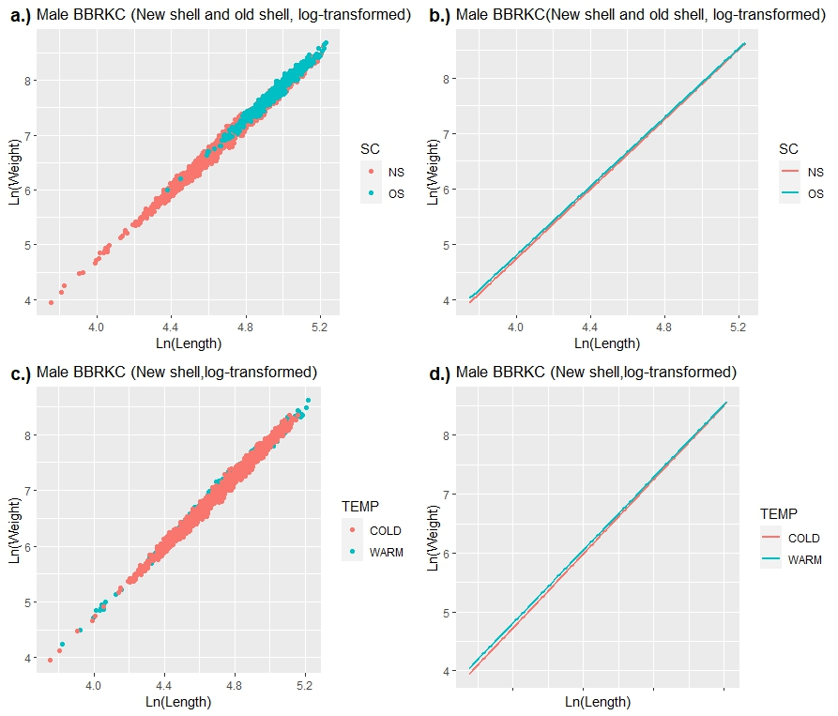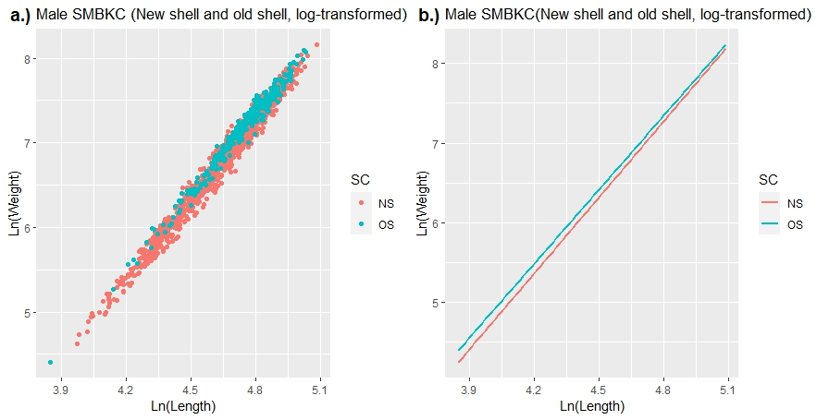

Figure 2. For St. Matthew Island blue king crab; a.) scatterplot of natural log transformed weights by natural log transformed carapace length measurements, with shell condition group indicated by color, b.) fitted linear model regression lines for shell condition groups.

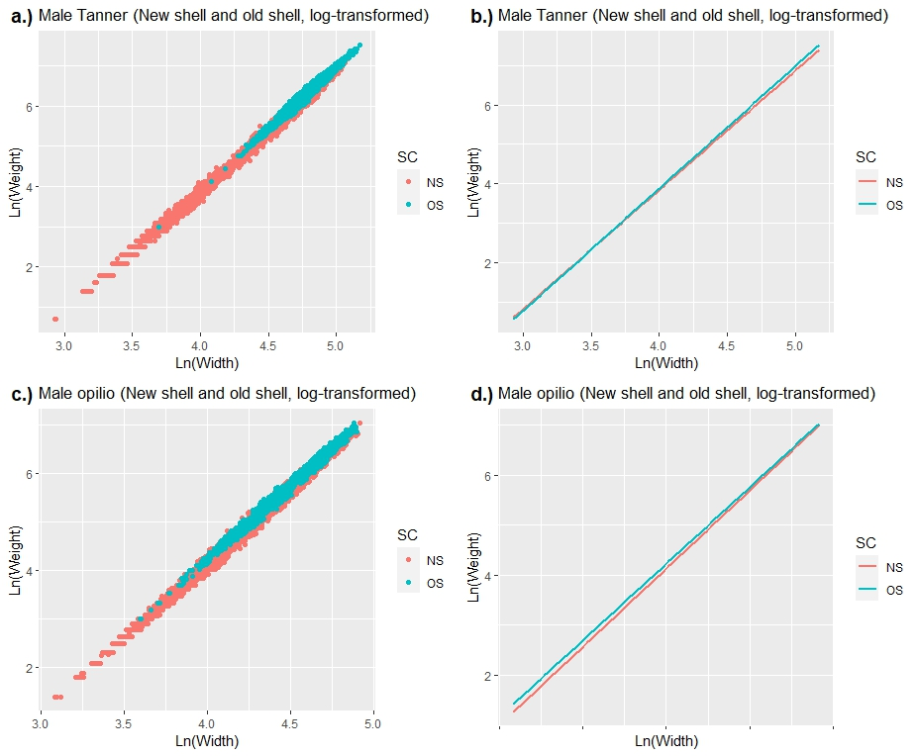

Figure 3. For Eastern Bering Sea Bairdi; a.) scatterplot of natural log transformed weights by natural log transformed carapace width measurements, with shell condition group indicated by color, b.) fitted linear model regression lines for shell condition group models. For Eastern Bering Sea opilio; c.) scatterplot of natural log transformed weights by natural log transformed carapace width measurements, with shell condition group indicated by color, d.) fitted linear model regression lines for shell condition group models.

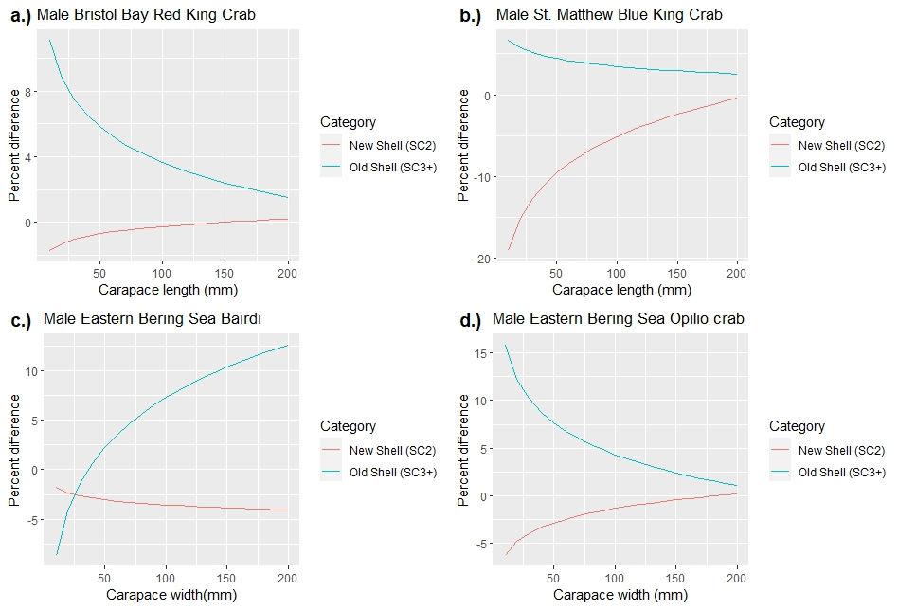

Figure 4. Percent difference in weight between shell condition specific size-weight model and current standard model by size for male a.) Bristol Bay red king crab, b.) St. Matthew blue king crab, c.) Eastern Bering Sea Bairdi crab and d.) Eastern Bering Sea opilio crab.

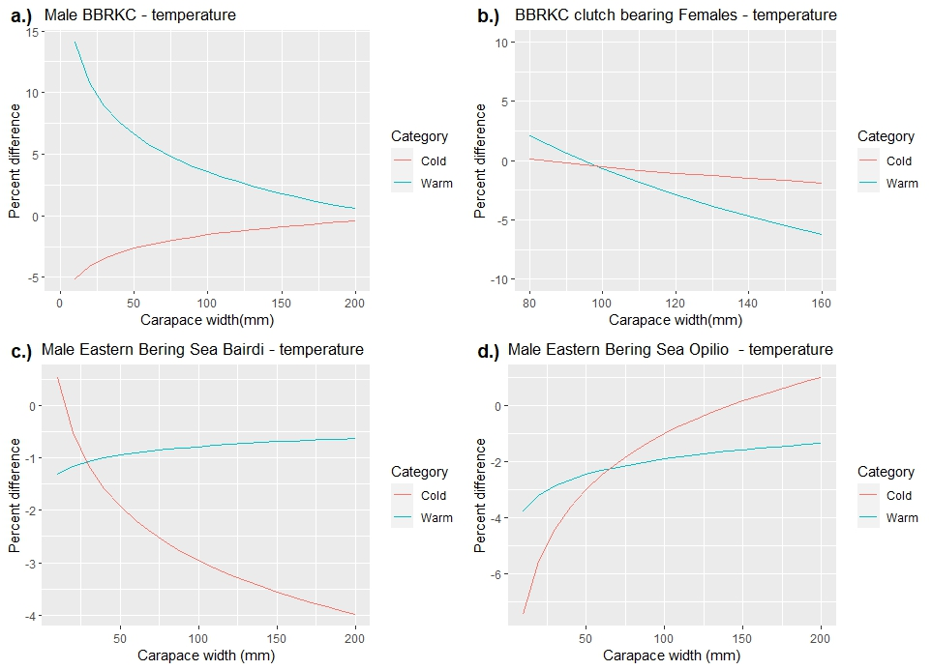

Figure 5. Percent difference in weight between thermal regime-based size-weight model and current standard model by size for newshell (SC2) a.) male BBRKC, b.) clutch bearing female BBRKC, c.) male Bairdi and d.) male opilio.

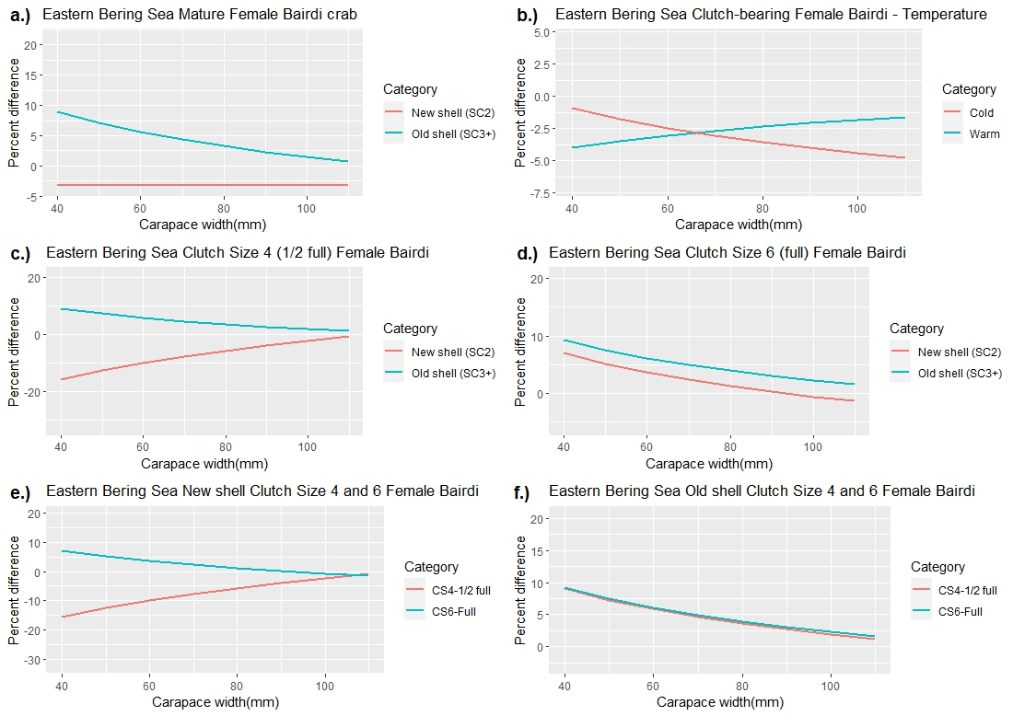

Figure 6. Percent difference in weight between female covariate-specific size-weight models and current standard models for female EBS Bairdi. Covariates are a.) shell condition, b.) temperature, c.) clutch size = 4 (half full), d.) clutch size = 6, e.) New shell + clutch size 4 and 6, f.) Old shell + clutch 4 and 6.

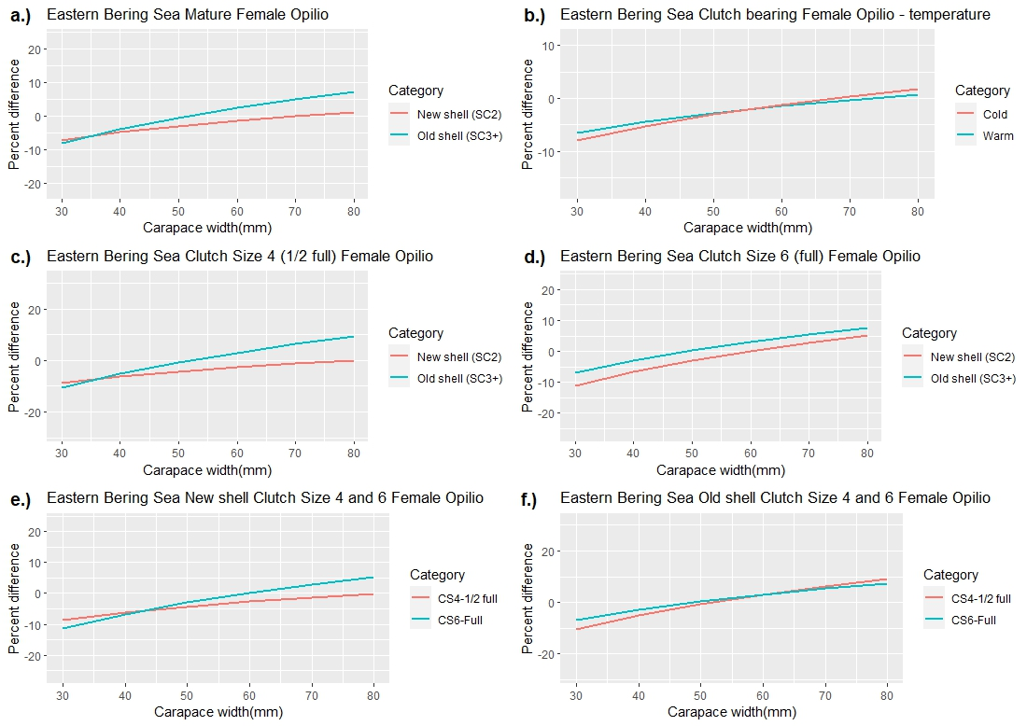

Figure 7. Percent difference in weight between female covariate-specific size-weight models and current standard models for female EBS opilio. Covariates are a.) shell condition, b.) temperature, c.) clutch-size = 4 (half full) and d.) clutch-size = 6, e.) New shell + clutch size 4 and 6, and f.) Old shell + clutch 4 and 6.

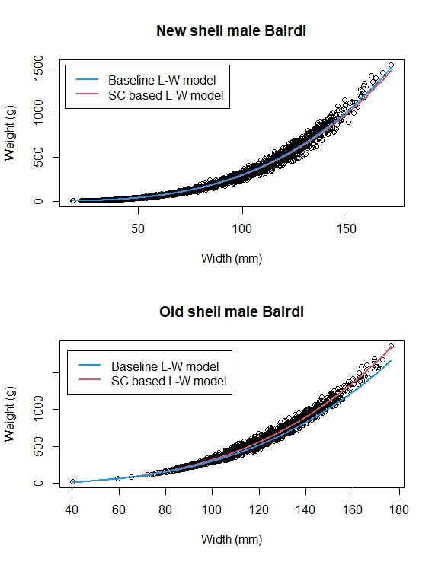

Figure 8. Comparison of baseline and bias-corrected, shell condition-based size-weight models for a.) new shell (NS) male Bairdi and b.) old shell (OS) male Bairdi. Note poor fit of baseline model to OS data, particularly at sizes >120 mm.

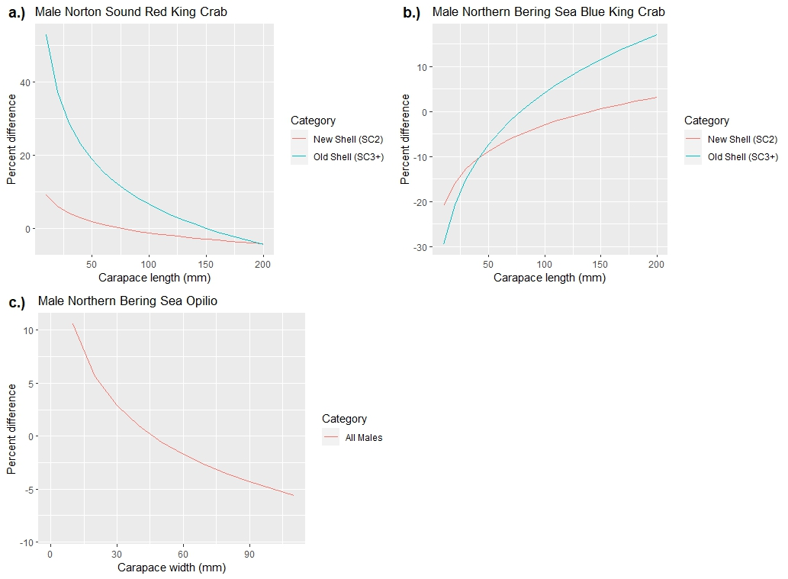

Figure 9. Percent difference in weight between shell condition specific size-weight model and current standard model by size for male a.) Norton Sound red king crab, and between Northern Bering Sea-specific size-weight models and Eastern Bering Sea models for b.) Northern Bering Sea blue king crab, and c.) Northern Bering Sea opilio crab.

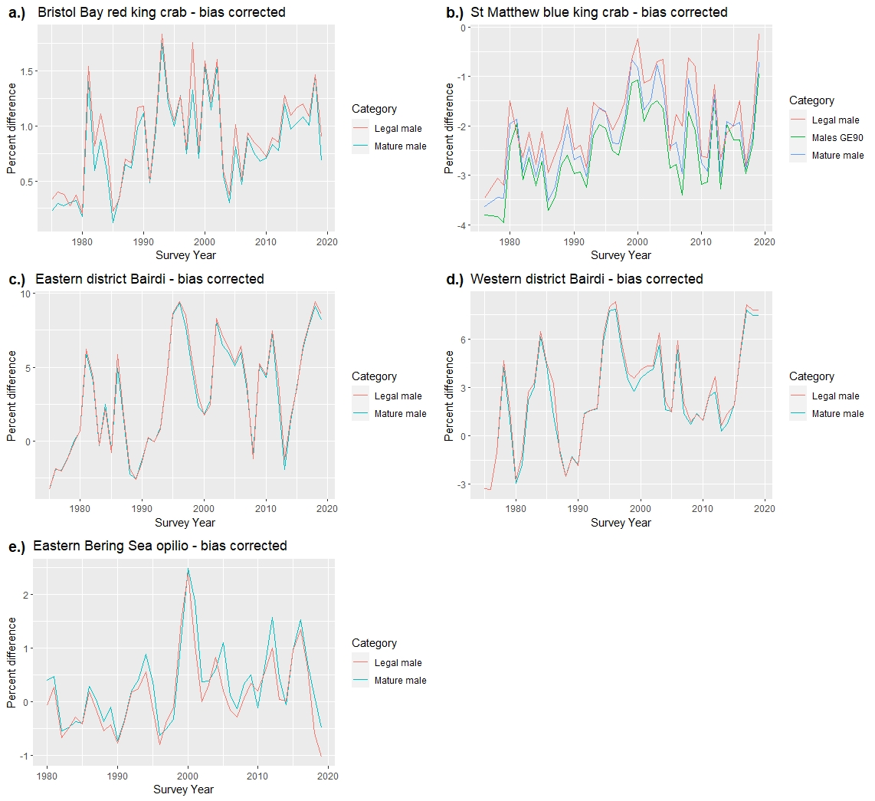

Figure 10. Percent difference in population biomass estimates for mature and legal to retain male size classes for; a.) Bristol Bay red king crab, b.) St. Matthew blue king crab, c.) Eastern district Bairdi crab, d.) Western district Bairdi crab and e.) Eastern Bering Sea opilio crab.